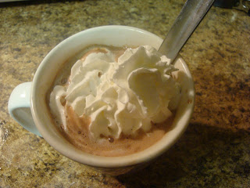

BF Basics: How to Make a Hot Protein Drink - http://www.bariatricfoodie.com/
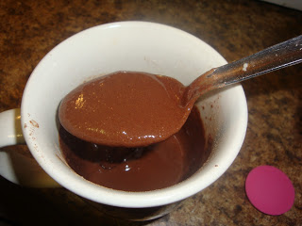
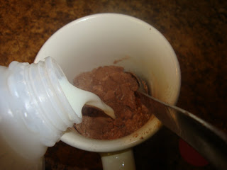
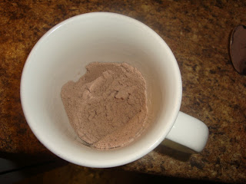
True or False: Once protein powder is heated above 130 degrees it is no good for you. (FALSE) The first and most important thing you should know about making protein drinks is what NOT to do with them. Do not simply add boiling water to a scoop of protein powder. Wait...that bears saying a bit louder. DO NOT SIMPLY ADD BOILING WATER TO A SCOOP OF PROTEIN POWDER. Yes, you can have piping hot protein drinks...but that's not the way to get them.
Now this, like many other aspects of post-WLS life, is one of those things where there are as many methods to do it as there are post-ops. This is my way. It doesn't involve any special machinery and even though I live in the 1800's and use a tea kettle, the whole thing takes all of about three minutes max.
Step One: I put just enough water in my teapot for my protein drink, ensuring it will boil up quickly. Then I get out my favorite coffee mug and put in a scoop of protein powder and whatever dry flavor additives I'm using (Splenda, unsweetened cocoa, instant coffee, etc.). What's in my cup? Tune in tomorrow and find out! But the important thing to remember here is to stir those ingredients thoroughly!
Step Two: I add just enough milk to form a thick paste that resembles pudding before it is totally set. Then I spend about a minute stirring it to remove ALL the lumps. This is important. If there are lumps in your paste, they will form rubbery floaties in your hot drink. You don't want that. So stir! When done, it looks something like this.
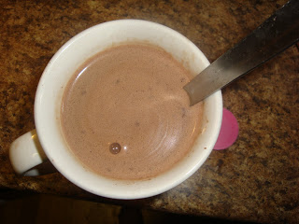
﻿Edited to add: I had a few folks ask me why I do this as opposed to heating up all milk and mixing in protein. I find that making a paste gets the protein all smooth before adding your hot liquids. I do water because my cup is 12 oz. and that much milk tends to be too rich. BUT if you'd like to do all milk, I still think making the paste is a good first step. It allows you to work out all your lumps before you add hot liquid. Lumps + hot liquids = floaties. Ew!
Step Three: By this time, my water is boiling. I couldn't photo this part (cuz the divas were asleep and unable to be my photographer)but basically it goes down like this. With one hand (for me, my left if that matters to anyone), I pour the hot water into the cup SLOWLY. With my other hand I continuously stir the mixture. Do this until your mug is full. If you've done everything right, it should look something like this.
...and isn't that lovely? And tomorrow you'll get to find out exactly WHAT it is (no, it's not cocoa, although I have a divine recipe for Salted Caramel Protein Cocoa if you'd like to try that). Now if it isn't hot enough for you, no problem! If you have a lump free drink, you can now microwave it and it will just fine...and as hot as you like it!
Ok, so let's talk troubleshooting:
"Nik, my hot drink is sludgy and thick!"
Use a bigger cup and add more water to your drink. Or use the same cup and less protein powder. Either way, that should yield a thinner drink.
"Nik, mine still had floaties! Blech!"

This could be for several reasons. You might have had a lump in your protein paste. Or you may have added the water too quickly. Or you may not have stirred enough at some stage. It sometimes takes a few tries to get it right.

"Nik, what's this frothy stuff at the top of my drink?"

Yes, there is that. Surprisingly, it isn't just from the protein. If you use Splenda, it froths up when you heat it as well. Give your drink a stir to get the sweetener incorprated. What's left you can either keep (it's a similar consistency as the froth on a latte) or skim it off. Your choice.

"Nik, I got it right! But now I'm addicted to hot protein drinks!"


Ok...and the problem is...?

For More Great Protein Drink Ideas...
Again, you'll find this hot protein drink tutorial - along with how to make your protein shakes into ice cream, popsicles, frosties and more - in The Bariatric Foodie Guide to Perfect Protein Shakes.

